Project 1 Report:

MakeMyVita : A Resume Builder Website

**Project Domain:** Web Development

**Project Name:** MakeMyVita

**Date:** 25th June 2024

**Author:** Aleti Teja Akshay Kumar (solo)

**MailID:** [tejaakshaykumar970@gmail.com](mailto:tejaakshaykumar970@gmail.com)

**GitHub Link**: [Website GITHUB-LINK ClickHere](https://github.com/Tejaakshaykumar/MakeMyVita-Resume-Builder-Website)

**Website Link**: https://makemyvita.netlify.app

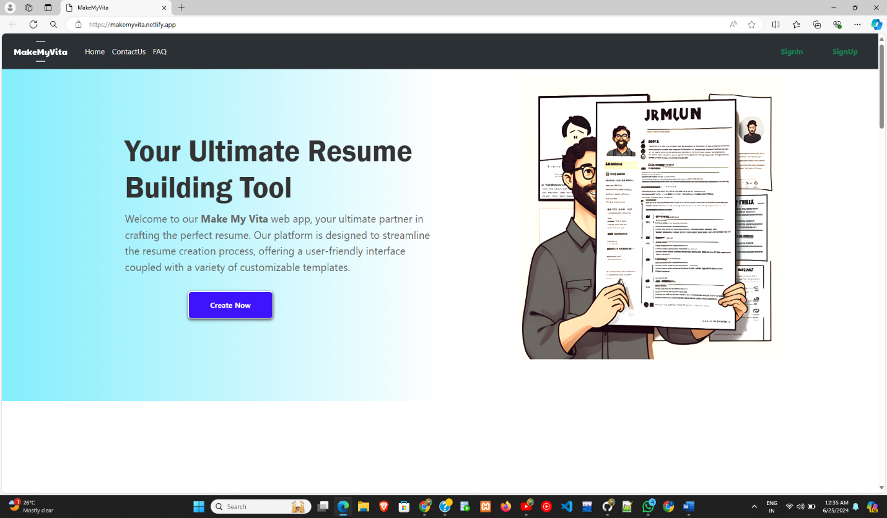

**Exective Summary**

*Overview:*

Make My Vita is a user-friendly web application designed to help users create professional resumes quickly and efficiently.

*Objectives:*

To provide a platform where users can build, customize, and download resumes.

*Key Deliverables:*

Functional website with resume templates, user accounts, customization options, and different file format download capability(locally).

*Timeline:* I Month

**Introduction**

#### Background:

Building a resume can be a real pain. It's time-consuming, confusing, and often leaves you feeling frustrated.

makemyvita.com specifically for students and job seekers like you and me. I want to help you craft resume that stands out from the crowd and lands you the interview you deserve.

#### Purpose:

To create a web application that allows users to easily generate resumes tailored to their professional needs.

#### Project Scope:

Development of a web-based resume builder with various templates and customization features with live preview of resume alongside.

Also with user authentication and storing the files which can be Viewed ,Download and Delete.

**Project Objectives**

#### Goals:

* + Develop an intuitive user interface.
  + Provide multiple resume templates.
  + Ensure resumes can be downloaded as
    - PDF
    - JPG
    - PNG
    - DOCX
  + Enable user account creation and management.
  + Live Preview of Resume
  + Customization

#### Target Audience:

* + Job seekers, students, professionals

#### Features:

* + User registration and login
  + Professional Templates
  + Real-time preview of the resume
  + Customization options (fonts, font-colors,Resume-color)
  + Multiple File Formats
  + Secure Storage

**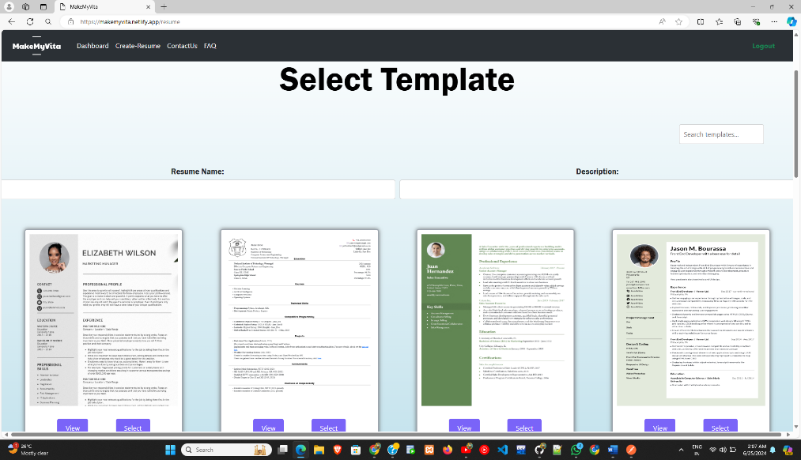  
can select template or can also search for template**

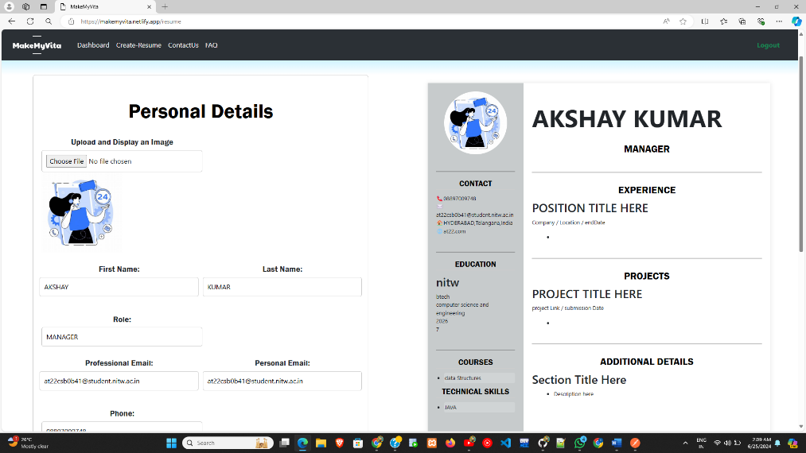

**Fill The section,also with live preview**

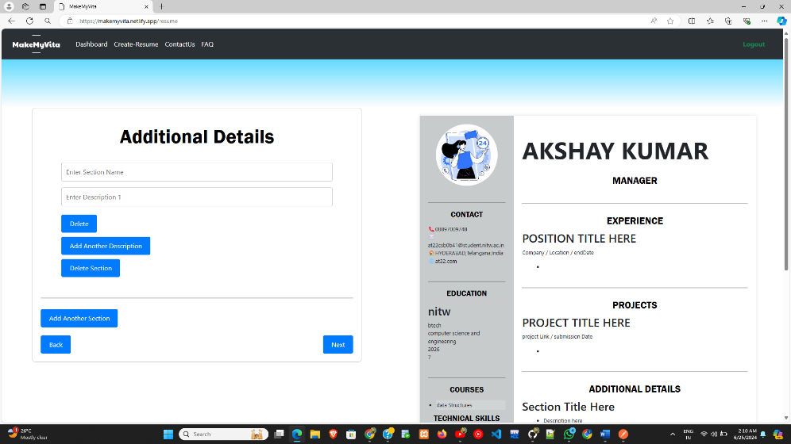

**Customize your section**

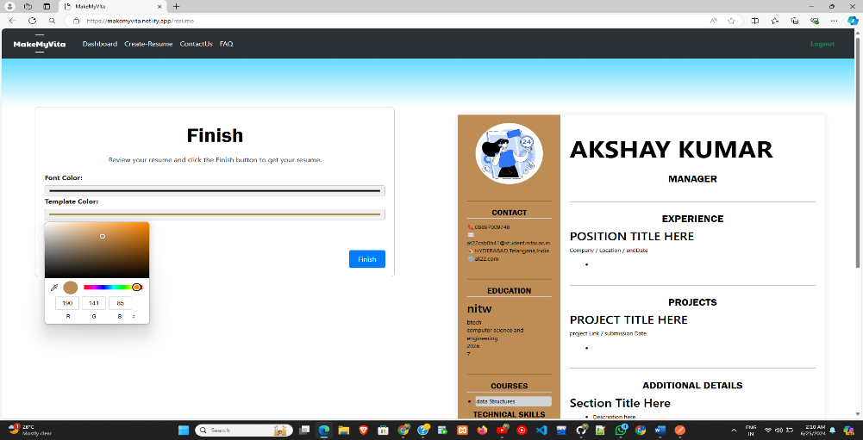

**Customize Fonts,Font-Color,Template-Color**

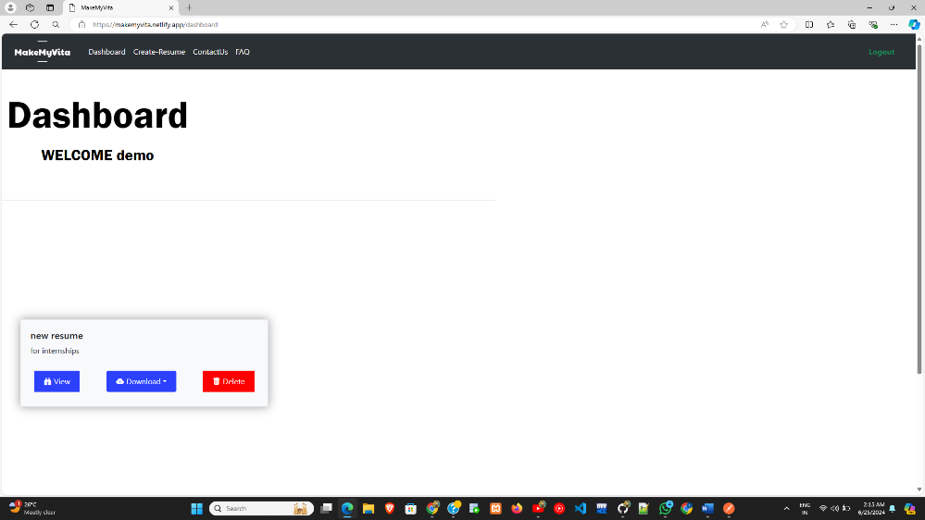

**Your Dashboard**

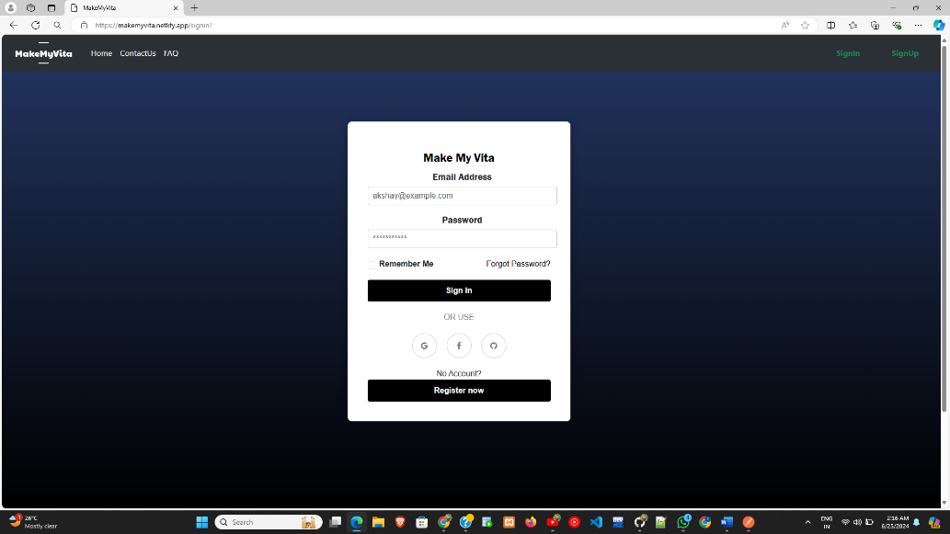

**Login page**

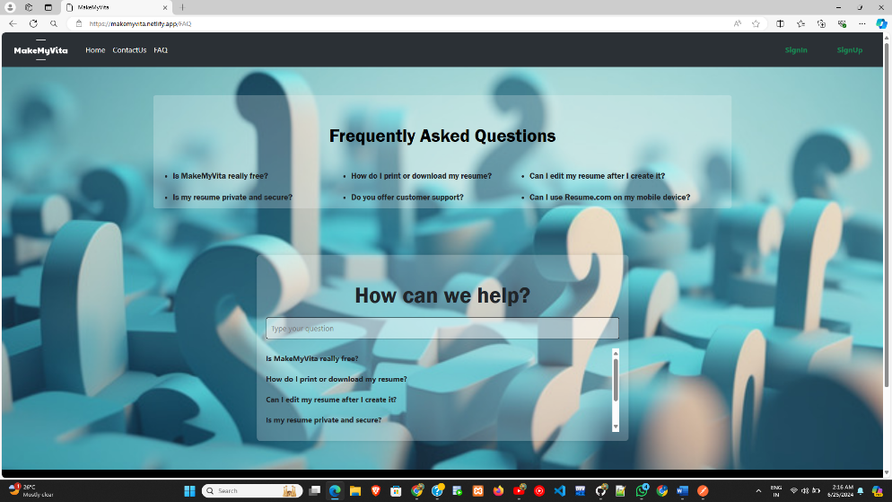

**Searcḥ or Click on FAQs**

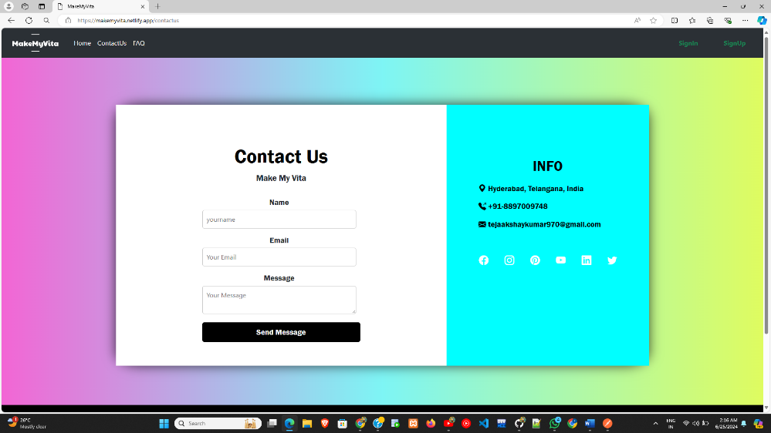

**Contact Us**

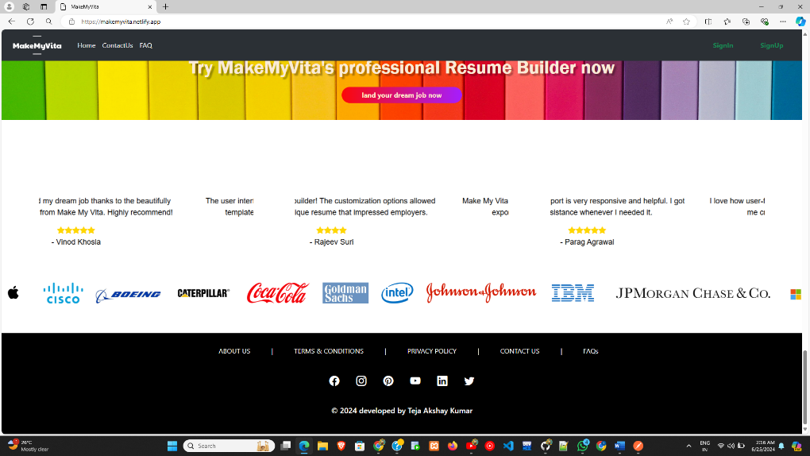

**Footer**

**Requirements Analysis**

#### Functional Requirements:

* + User authentication and profile management.
  + Template selection and customization.
  + Real-time preview.
  + File export.

#### Non-functional Requirements:

* + Performance optimization.
  + Security measures (data protection, secure login).
  + Usability and accessibility.

#### Technical Requirements:

* + MongoDB, Express.js, React.js, Node.js, JavaScript, CSS, HTML
  + Backend Testing -Postman
  + Hosting FrontEnd-Netlify
  + Hosting Backend-Render
  + Version control-Git
  + Repository-GitHub
  + Bootstrap
  + Firebase Authentication

**Project Planning**

#### Responsibilities:

* + Responsible for the entire codebase
  + Front-end development ( CSS, JavaScript, React.js).
  + Back-end development (Node.js, Express, MongoDB).
  + Implementing key features such as user authentication, template selection,live preview and file export.
  + Integrating third-party services (firebase Auth).
  + Developing and executing test plans and test cases.
  + Verifying bug fixes and performing regression testing.
  + Focused on the visual aspects of the website.
  + Ensuring to meets user expectations.

#### Timeline and Milestones:

* + Planning and requirement gathering: 1 weeks
  + Design: 1 weeks
  + Development: 4 weeks
  + Testing: 1 weeks
  + Deployment: 1 Day

Note: All have done within a month, but simultaneously.

**Implementation**

#### Development Environment:

* + Local development setup with staging environment.

#### Version Control:

* + Use Git for version control and GitHub for repository hosting.

#### Third-Party Integrations:

* + Bootstrap.
  + Firebase
  + Slider.js
  + Tostify

**Testing**

#### Testing Strategy:

* + Unit testing for individual components.
  + Integration testing for combined functionality.
  + System testing for overall application.
  + User Acceptance Testing (UAT).

*Application:* Postman

#### Bug Tracking: Used console.log() for tracking errors.

**Deployment**

#### Deployment Plan:

* + Deploy on Netlify and Render.

#### Hosting Details:

* + Netlify hosting The Frontend.
  + Render hosting The Backend

#### Backup and Recovery:

* + Regular backups.

**Bugs(on Hosting)**

#### Download:

* + Pdf cannot be be perfect(it might loose few border portion of Resume)
  + Downloading Image is Recommended

#### Creating Resume:

* + after creating new Resume wait For few seconds(atleast 10sec since resume takes time to post data and update) and refresh the dashboard.

### Conclusion

#### Summary:

Make My Vita successfully achieved its objective of providing a user-friendly platform for creating professional resumes. The project encompassed the development of a web application with features such as user authentication, multiple resume templates, real-time preview, customization options, and multi-format file export. Despite some hosting-related issues, the site is fully functional and accessible.

#### Future Recommendations:

* **Enhance Performance:** Optimize loading times, especially for resume fetching and saving.
* **Improve Download Functionality:** Resolve issues with file download on the hosting platform.
* **Additional Features:** Introduce more customization options,forgot password, additional templates, and mobile app versions.

#### Lessons Learned:

* **User Feedback:** Gained valuable insights from user feedback for continuous improvement.
* **Development Workflow:** Reinforced the importance of thorough testing and version control in solo development projects.